unCaptcha:
A Low-Resource Defeat of reCaptcha’s Audio Challenge

George Hughey Dave Levin

University of Maryland

Abstract
CAPTCHAs are the Internet’s first line of defense against automated account creation and service abuse. Google’s reCaptcha, one of the most popular captcha systems, is currently used by hundreds of thousands of websites to protect against automated attackers by testing whether a user is truly human. This paper presents unCaptcha, an automated system that can solve reCaptcha’s most difficult auditory challenges with high success rate. In this paper, we will show two separate, yet related, defeats of Google’s reCaptcha. The first attack was performed in April, 2017, and we found that our unCaptcha system solved captchas with 85.15% accuracy in 5.42 seconds. In an effort to make the Internet a safer place for the everyday user, we notified Google about the attack, and it was fixed in August, 2017. However, Google’s fixes did not improve the overall security of the system, and by June, 2018, we created unCaptcha2, a system that can successfully solve captchas with over 90% accuracy. We again notified Google and coordinated a responsible disclosure of the attack with them in December, 2018. unCaptcha2 is still successful at solving reCaptcha’s challenges, and we believe that Google’s team is currently working on a complete overhaul of their reCaptcha system.
Both systems exploit vulnerabilities in audio captchas. reCaptcha gives the user the ability to choose between a visual captcha and an audio captcha. Most users are familiar with the visual captcha, which asks the user to select all pictures that contain one type of object, such as a storefront, traffic light, or car. However, for visually impaired users, Google offers an auditory component, which both versions of unCaptcha attack. unCaptcha combines multiple publicly available speech-to-text systems with a novel homophone mapping to solve captchas. We evaluated unCaptcha over 450 captchas – enough to get a good baseline for how accurate the system is without damaging any of the platforms. After unCaptcha was released, Google fundamentally changed their design of auditory captchas. As a result, a complete overhaul of the unCaptcha system was required in unCaptcha2. The second version only requires a single speech-to-text system, and was evaluated over 538 captchas. unCaptcha2 was found to be 90.1% successful over these captchas, and took fewer than 3 seconds to complete.
The first section of this thesis will explain the unCaptcha system and its evaluation, while the second chapter will focus on unCaptcha2. We recognize that much of the captcha ecosystem is a cat-and-mouse game: as attackers become better, they can solve more captchas, which in turn inspires better captchas for attackers to attack. With unCaptcha, we enter this cat-and-mouse game, notifying Google every step of the way so they can improve their captchas and prevent real-world attackers from exploiting everyday users. Interestingly, to Google, reCaptcha’s purpose is twofold: to prevent automated attackers and to improve their AI (as Google actually uses the results people enter in their captchas to train their AI systems). Our work shows that this traditional economy of captchas – using answers to train AI and making that AI publicly available – is fundamentally flawed and requires a complete overhaul of the traditional captcha economy. The final chapter of this thesis will be some insight into this cat-and-mouse game, our responsible disclosure with Google, and how captchas can improve as AI improves.

Chapter 1: unCaptcha
1 Introduction
CAPTCHAs (the Completely Automated Public Turing tests to tell Computers and Humans Apart) are defense systems designed to protect against automated account creation and service abuse by presenting users with a challenge that is easy for humans to solve but difficult for computers [27, 8]. Captchas are used extensively online as a defense against automated bots and Sybil attacks [4], as well as preventing spam. For instance, many online registration platforms, from social media services to email to ticketing systems [8], require the user to solve a captcha during registration to prevent automated creation of fake accounts. In a similar vein, some online services have recently begun requiring Tor clients to solve captchas before delivering web content [11, 16].
The security of captchas is paramount to protecting services on the Internet from these attacks. As the spread of news and information is increasingly driven by user content on sites like Twitter, YouTube, and Reddit, bots that could defeat the captcha system and register a disproportionate number of accounts could theoretically control the flow of information en masse [29]. It is therefore unsurprising that captchas have been the target of attack for researchers and attackers for years [27, 2, 25, 28, 21, 32, 13, 1, 22].
Until recently, captchas have featured distorted text that users must correctly type to pass. Bursztein et al. [1] showed these text-based captchas to be insecure by demonstrating a system with near-complete (98%) accuracy. As a result, text-based captchas have been largely phased out in favor of image captchas (discussed at greater length in Section 2).
However, visually impaired users are incapable of solving these visual captchas, prompting the creation of audio captchas [27]. Typical audio captchas consist of different speakers saying words or digits at randomly spaced intervals at a variable pitch or speed, often with an accent and distortion/noise [27]. To solve the captcha, a user must correctly identify the digits or words spoken in the audio clip.
Attacks have been demonstrated on these audio captchas with varying degrees of success in the past. This is usually done by training local machine-learning models to identify the spoken words [2, 25], a high-resource and time-consuming approach. Additionally, although researchers have explored using online speech recognition services, including Sphinx [2] or Google Speech Recognition [18], these services have not been accurate enough to compete with offline services or solve the captcha reliably.
We present unCaptcha, a low-resource, fully automated attack on Google’s 2017 reCaptcha audio captcha. unCaptcha is viable for even a low-resource attacker; rather than perform its own analysis locally, unCaptcha leverages free, publicly-available speech recognition services, and performs a minimal phonetic mapping to boost accuracy. Using a free Amazon Elastic Compute Cluster (EC2) t2.micro instance, we demonstrate that unCaptcha can solve reCaptcha’s audio challenges with 85.15% accuracy in 5.4 seconds, on average. As the audio captcha is sufficient for passing the entire reCaptcha system, this work presents a near complete defeat of the reCaptcha system, rendering the hundreds of thousands of sites that rely on it vulnerable to abuse or automated attacks. We demonstrate that it takes far fewer resources to mount a high accuracy defeat of the reCaptcha system than previously thought, and make suggestions for more secure auditory captcha designs.
The rest of this paper is organized as follows. In the next section, we provide an overview of related work. Section 3 details more background into Google’s reCaptcha system, and Section 4 describes unCaptcha’s design. Finally, we analyze and evaluate unCaptcha in Section 5.
2 Related Work
Captchas have long been the target of automated attacks. Due to the breadth of literature, we will focus only on attacks concerning auditory captchas. Almost a decade ago, Kochanski et al. investigated the security of audio captchas and developed a synthetic benchmark for evaluating automatic solvers [12]. This work concluded that humans vastly outperform automated speech recognition systems (when audio noise/distortion is added to spoken digits), and has guided the design of modern audio captchas. Further independent studies deployed a two-phase segment-then-classify approach and successfully broke older versions of Google and Yahoo audio captchas [26, 21]. These two-phase solvers usually operate by first extracting portions of the captcha that contain the digit, and then running pre-trained machine learning algorithms to classify those individual digits, rather than classifying them all at once [24].
In 2012, a research team developed the Decaptcha system, a high performance auditory captcha solver to attack eBay’s captcha system [2]. Decaptcha was a two-phase solver that first examined energy spikes in the audio file to segment by digit. Using a supervised learning algorithm and a large corpus of previously annotated eBay captchas, researchers developed a powerful model that could recognize digits. Decaptcha achieved 75% accuracy on tens of thousands of captchas on their largest machine learning model. Burzstein et al. also defined four threat models for attackers, and explored the potential damage each could do. Although the advanced and high-level attackers, defined to have tens to hundreds of thousands of IP addresses and tremendous local resources, could achieve high accuracy with their Decaptcha model, the defined low and even medium resource attackers achieved only 10% success [2]. Such a model discrepancy is common: many existing captcha solutions assume high attacker resources, including cores, bandwidth, IP addresses, and more, to achieve high accuracy solving [27, 2, 25, 28, 21, 32].
In 2012, a Defcon group demonstrated a successful attack on the original iteration of reCaptcha’s auditory captcha [25]. Using a large, powerful, locally trained neural network, they achieved over 99% accuracy on the original audio captcha system. After Google updated the auditory captcha system to change it from words to digits, inject background noise, and vary number of digits to mitigate their vulnerability, the researchers rewrote their tool and still achieved 61% accuracy. After a third reCaptcha update (which was very similar to the original iteration, according to the researchers), they again defeated it with 60% accuracy using their large neural network. Their tremendous success was limited only by their need for a large corpus of training data; gigabytes of data were used for training in the original attacks [25]. A similar high-resource attack in 2013 using Hidden-Markov Models was also highly successful, solving these audio captchas with 52% accuracy [20].
In 2016, a proof of concept work was done to attack the newly updated audio captcha [18]. This work demonstrated that it was possible to submit the entire captcha audio to Google Speech Recognition and get a candidate solution. No accuracy measures were published, but the researcher noted that on the 4-5 digit captcha, it was successful. However, shortly after this work, the new 2017 captcha was released, introducing the longer audio captchas (10 digits) and background noise to each digit. Presumably, the background noise lowered the digit classification accuracy and the longer captcha required a higher accuracy (90%) to pass, and therefore the new captcha broke this methodology. Since this work only used Google’s Speech Recognition API and did not segment the digits before analysis, ReCaptcha’s protection against this attack was successful. Still, this work serves as a foundation for our approach to break the 2017 reCaptcha.
Threat Model
Prior work has generally assumed that attackers against captcha systems are well-resourced. In particular, the standard threat model involves an attacker who can attack the captcha tens or hundreds of thousands of times for a relatively small number of successes, and can scale this attack to abuse services.
Tightly coupled with the captcha threat model is what level of accuracy is considered sufficient to “defeat” a given captcha system. An attacker with many resources can afford a lower success rate, and thus some have argued that even a success rate of 1/10,000 is sufficient to threaten the integrity of services against an advanced attacker [3]. Others assume attackers have fewer resources (limited training data and/or processing power) and define 1% success accuracy as sufficient to defeat a captcha system [2]. Still others raise the bar to only classifying success above a higher threshold, such as 50% or 70% [27].
In our work, we will assume an attacker with limited resources; unlike previous works attacking captchas, our threat model limits the attacker to one computer, one IP address, a small amount of RAM and limited training data (less than 100MB). Therefore, we aim for accuracy benchmarks above 50%, as a low-resource attacker cannot afford a lower percentage of success. Other works have achieved low-resource attacks on captchas before: Yan et al. [32] successfully produced a low-resource attack on the Microsoft text-based captcha in 2008, prompting Microsoft to request the work to be held in confidence for months while a replacement system was built. To our knowledge, no similar low-resource attacks have been replicated for auditory captchas.
3 reCaptcha Background
The reCaptcha system relies on an advanced risk analysis engine. As the user interacts with reCaptcha (clicking buttons and typing), the system determines a level of suspicion for that user. Today, many users will find that they simply need to click the checkbox and be verified without needing to solve a captcha. This occurs when the reCaptcha is fairly confident that the user is human and not an automated attacker (this is called the “noCaptcha reCaptcha”). If the system is unsure if the user is a human (but is not highly suspicious either), it will deliver a moderate challenge to the user (an easy image problem or a short audio string of numbers to transcribe). This often occurs when a user does not yet have a long enough history of interaction with Google. However, as the reCaptcha system becomes increasingly suspicious, it delivers harder challenges: 10 digits in the audio challenge, or prompting the user to solve multiple challenges. By default, a user with no past history with Google services will be automatically given the most difficult challenge. It is these most difficult challenges that unCaptcha attempts to solve. In the backend, a developer can enable different levels of security for reCaptcha on a 3 point scale between “Easiest for users” and “Most secure”. Through our experimentation, we could discern no difference in the level of difficulty of the captcha itself across the three settings, suggesting that only auxiliary security checks are enabled in the higher security settings.
Although the new reCaptcha system was introduced in 2014 to replace the traditional “distorted text” captcha, not much is known about its inner workings. Google has protected the inner design of reCaptcha heavily, releasing few details about how their software works. The captcha system is run from an encrypted, isolated VM (Virtual Machine) in JavaScript with a unique bytecode language. To make reverse engineering even more difficult, the bytecode has direct access to JavaScript variables of its own interpreter, and changes its own decryption key and even its own opcodes numbers at many points during its own execution. A full working disassembler and decompiler for the system was released, and it was determined that the captcha system, in addition to confirming the actual captcha solving, checked for the presence of: valid plugins; a valid user-agent string; a valid screen resolution; execution time; computer timezone; number of click, keyboard, or touch actions in the iframe of the captcha; many browser-specific functions and CSS rules; canvas rendering properties; server side cookies; and likely more [15].
In 2016, a further analysis by Sivakorn et al. [23] of the reCaptcha system explored the weaknesses of the initial implementation of the image captcha. It is important to note that the image captcha has changed since that paper, and their methodology is no longer sufficient to defeat the captcha. However, their analysis of the captcha’s risk analysis system lends insight into its inner workings. In particular, Silvakorn et al. found that Google’s tracking cookies play an integral role in the captcha’s defenses. The captcha system is made aware of every time a user interacts with a Google service (or a page with Google’s tracking cookies, such as Google analytics). After just 9 days of automated browsing across different Google services, their bots’ tracking cookie was sufficient to fool the risk analysis system into thinking they were human, and checking off the box. However, their experiments revealed each cookie could only immediately complete 8 captchas per day before needing to solve additional challenges. Their results also showed that the reCaptcha system attempts to fingerprint the browser, using canvas rendering techniques, comparing the user-agent to what the browser reports, and potentially more [23]. Despite these impressive efforts of the risk analysis engine to identify a bot before the captcha, as we will show next, reCaptcha still remains susceptible to low-resource attacks to its audio challenge.
4 unCaptcha Design
In this section, we present the design and methodology of unCaptcha, a novel, low-resource attack against the auditory challenges in Google’s reCaptcha. unCaptcha is a fully automated, end-to-end attack, and comprises four key steps: (1) Obtaining the audio sample, (2) Segmenting the audio into per-digit sound bites, (3) Analyzing the sound bites, and finally (4) Entering the captcha solution. We present each of these in turn. See Figure 1 for a diagram of the design.
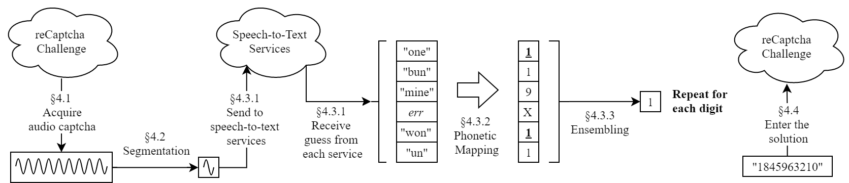
Figure 1: The overall design of unCaptcha. Note that speech-to-text analysis, phonetic mapping, and ensembling are applied to each digit separately.
4.1 Acquiring Audio Captchas
Our primary technical contribution lies in our ability to accurately analyze audio challenges, but a full end-to-end attack must also be able to first obtain the audio challenge. This is nontrivial for a bot, as the reCaptcha system uses multiple heuristics to distinguish between humans and bots, including checks for fake browser agents, headless browsers, javascript checks, and more [15]. Important among these is the detection of keyboard and mouse inputs that appear “inorganic”— for instance, moving the mouse at superhuman speeds or in perfectly straight lines. We describe here how unCaptcha bypasses these; we use the popular Reddit website as a running example, which uses reCaptcha to defend against bot account creation. Note that some of the more aggressive security checks are disabled in reCaptcha’s lower security levels, but at the time of writing, our attack was fully functional against reCaptcha on highest security level with all security features enabled. This methodology could be applied to any of the hundreds of thousands of services that use Google’s reCaptcha.
Using the popular browser automation software Selenium, unCaptcha finds a functioning HTTP proxy to mask its connection from GatherProxy. It uses Firefox to first navigate to Reddit.com, and performs some minor page interaction. It clicks the link to create an account, which opens a “create new account” modal box. The bot then generates a random username, password, and email, clicks into each field, and types it as a human would, with random amounts of time between each keystroke so as to fool reCaptcha. This is just a proof of concept, since no additional processing is done to check if the username or email is valid; these fields are only filled out to initiate the captcha.
It is interesting to note here that our build of unCaptcha was tested on both Mac OS X and Linux (Ubuntu), but the attack only initially worked successfully on Linux, as reCaptcha could seemingly detect the use of Selenium on OS X. This broken detection of browser automation on Linux was a critical vulnerability that in part originally enabled this attack. However, we were later able to custom compile a Mac OS X Selenium ChromeDriver that evaded detection by simply renaming hardcoded DOM-accessible ChromeDriver-specific variables, suggesting that reCaptcha’s Selenium detection system is still insufficient.
Once the username and password are filled, the reCaptcha appears. unCaptcha locates the “I’m not a robot” checkbox, and clicks it. Although we engineered the typing to be pseudo-organic, the mouse movements were left to Selenium’s default, inorganic behavior. Across all captcha attacks, reCaptcha never seemed to pick up on these mouse movements; we hypothesize that reCaptcha does not actually examine mouse movement patterns, but just a set number of events generated from mouse usage (hover, unhover, etc), which are actually generated by browser automation software by default.
Next, the reCaptcha system generates a new iframe with the actual reCaptcha challenge. From here, the bot switches to an audio captcha, downloads the audio payload from the page, and clicks the “PLAY” button, to mimic a normal, listening user.
4.2 Audio Pre-processing
Following the methodologies in other works, the retrieved audio file is first segmented before recognition. Google’s current audio reCaptcha does not have continuous background noise to interfere with segmentation, and relies entirely on distortion within the sound bites themselves for protection. Therefore, segmentation is surprisingly straightforward; unCaptcha simply splits the audio file by periods of silence using amplitude analysis to separate each spoken digit.
4.3 Analyzing the Audio
unCaptcha’s primary contribution is in how it analyzes audio in an accurate and low-resource manner. Similar to ReBreakCaptcha [18], we make use of existing online speech-to-text services, but we apply two key additional steps: phonetic mapping and ensembling. We describe these in the following subsections.
4.3.1 Speech Recognition Services
After retrieving and segmenting the audio file, unCaptcha uploads each sound bite to a set of different free online speech recognition services. All of these services were registered within a day and required no cost. In our implementation, we use six: Google Cloud, Bing Speech Recognition, IBM Bluemix, Google Speech API, Wit-AI, and Sphinx (available through python’s speechrecognition library). We originally implemented a seventh service, Houndify, but it performed so poorly in comparison in the presence of distortion that we later removed it. By comparison, ReBreakCaptcha used only a single online service (Google Speech API). However, as we show in Section 5, using multiple speech recognition tools is critical to achieving high accuracy.
For each sound bite, each of these services returns a candidate text transcription. It is important to note that most of these services are designed for generic speech recognition, and unlike many prior approaches with specifically trained models to classify spoken digits, these multipurpose services frequently confuse digits with words. We address this issue with phonetic mapping (Section 4.3.2). Additionally, we have found some services to be significantly more accurate than others. We address this by borrowing a technique from machine learning: ensembling (Section 4.3.3).
4.3.2 Phonetic Mapping
Since these services support general speech recognition (not only digits), we employ two layers of phonetic mapping: (1) exact-homophone, and (2) near-homophone.
The preliminary layer of phonetic processing maps common mistakes in speech recognition back to corresponding numerical digits. We map homophones of each digit back to its numerical form (such as “to”/“too” 7→ “2,” “for”/“fore” 7→ “4”). Frequently, services also spell out the digit instead of returning just the digit. For example, an API might return the word “four” instead of “4”. Therefore, we mapped the spelled-out versions of all ten digits to their respective numbers as well in the preliminary layer.
In addition to the basic homophone mapping, a second layer of phonetic processing is needed. Minor distortion, heavily accented voices, or short sound bites negatively affected the service’s ability to correctly identify the digit. The services would often return words that sounded phonetically similar to the correct digit. Therefore, we added a heuristics-based mapping layer to correct for common mistakes made by the services. In our initial development, almost 100 captchas were solved by hand as a test set to curate the heuristic list of near-homophones. With just 36 near-homophones, unCaptcha solved captchas at a rate greater than 50%. While this list of near-homophones was manually created, it could be also done in an unsupervised manner with natural language processing. Some examples of near-homophones include “free” for “3”, “sex” for “6”, and “mine” for “9”. Few of these near-homophones are actually needed for a basic level of success, but given the wide array of distortion, more mappings vastly improved accuracy overall.
We further extended our phonetic mapping to include partial matches for distinctive sounds of certain digit; for example, words ending in “icks” on average should be classified as a “6”, responses containing “ee” would be classified as a “3”, etc. In total, unCaptcha’s heuristic contains 129 of these homophones, near-homophones, and partial matches which it uses to assemble a candidate solution string of digits. These homophones were curated manually and chosen systematically, first using a trial and error approach, making sure that common homophones were included. For fine-tuning, we employed a statistical analysis of common errors from the speechto-text services, which identified other less intuitive mappings, such as “you know” for the number 0 (this alone increased our captcha success rate by 0.6%). A more comprehensive collection of such near-homophones and partial matches would only improve overall accuracy; however, our manually curated list was sufficient for the initial build of unCaptcha.
Finally, we note that we did not include any of the audio samples we used in constructing our phonetic mapping when evaluating unCaptcha (Section 5).
4.3.3 Ensembling
After performing phonetic mapping on each of the individual speech recognition services’ predictions, we “ensemble” their responses to obtain a single answer. In essence, each candidate answer gets a weighted vote; the answer with the highest weight wins. We assign weights in two ways.
Throughout our evaluation, we observed that some online speech recognition services were more accurate than others at correctly identifying digits, and therefore the balance of our heuristic model was partially driven by these differences in accuracy. For example, during initial testing, we discovered that Google Cloud was much better than Sphinx at correctly identifying digits; therefore, results from Google Cloud later were given a higher weighting than from Sphinx.
An additional problem arises with this ensembling approach: multiple services returning different, potentially valid identifications. This was common with distorted digits, particularly with harder to distinguish digits. Some near-homophones began to fall under multiple categories, for example,“fine” for “5” and for “9”, causing many false positives. To combat this, we assigned a weighting value based on the phonetic similarity of specific words and used a weighted majority vote to determine the digit. Exact-homophones (such as “too” or “for”) were given a high weighting value, while more phonetically different near-homophone words that could be confused between categories (such as “fine”) were given a low weighting value. This change dramatically improved accuracy (just over 65%). Phonetic analysis of additional common mistakes also showed more nearhomophones, such as “brain” for 9, “we” for “3”, and “they have” (they’ve) for “8”. This ensembling approach and phonetic mapping layer sets this work apart from existing auditory attack methodologies, such as [18].
4.4 Entering the Solution
After a candidate string of digits has been assembled, unCaptcha organically (with uniform timing randomness between each character) types the solution into the field and clicks the “Verify” button. Continuing with our running example of Reddit: When successful, the bot could go forward to creating an account. Although we could have made Reddit accounts with every successful captcha solution, we chose to make only a small number (fewer than 10) of accounts as a proof of concept.
5 Evaluation
We tested unCaptcha on 459 hand-annotated captchas on a free-tier Amazon t2.micro EC2 instance, with 1 virtual core, 8GB storage, and 1GB of RAM. All testing was done on reCaptcha’s most difficult, 10-digit captchas.
5.1 Base, Per-digit Accuracy
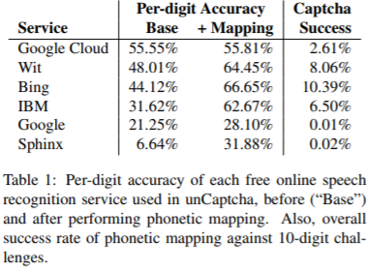
We begin by investigating the base accuracy provided by each of the services used in unCaptcha. Table 1 shows the per-digit accuracy of each of the six services we use, sorted in decreasing order of base accuracy. As these results show, using a single service alone (such as ReBreakCaptcha, which used Google) would not lead to high accuracy for 10-digit challenges.
5.2 Benefit of Phonetic Mapping
Next, we explore the effectiveness of unCaptcha’s phonetic mapping (Section 4.3.2). Each service’s per-digit accuracy after phonetic mapping is shown in the “+Mapping” column in Table 1. Across all the captchas, the phonetic processing increased the accuracy by an average of 17.04%, though some services saw far greater improvements than others. For example, Google Cloud needed almost no improvements— nearly all of its returned suggestions were either digits or exact-homophones of the digits. Wit AI performed similarly well, but faltered significantly with digits 0, 6, and 8. Bing’s speech-to-text software performed moderately well across the board, again with the exception of the digit 6. Indeed, we see a preponderance of errors with the digit 6; we return to this point in Section 5.4.
5.3 Benefit of Ensembling
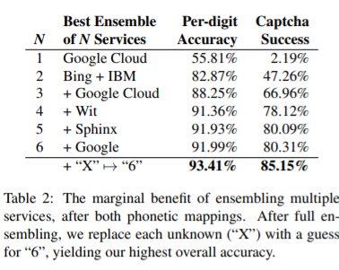
Even if some services are unable to identify a sound bite, with ensembling (Section 4.3.3), it is likely that another one can. Table 2 shows the maximum level of success depending on the number of services used. This table shows that it multiple services before the success rate can reach the 50% success rate mark. After four services, the marginal benefit drops off steeply. At this point, the services are capable of correctly classifying 91.36% of the digits. Additional services have difficulty classifying the remaining 8.64% digits, so they barely improve the success rate.
5.4 unCaptcha Accuracy
Putting all of the techniques together, we now present unCaptcha’s overall accuracy.
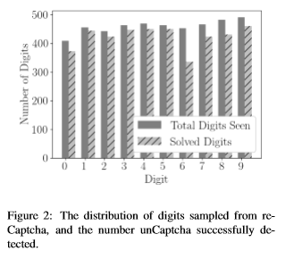
Per-digit accuracy As Table 2 shows, after the service aggregation and phonetic mapping, unCaptcha achieves a per-digit accuracy of 91.99%. Figure 2 shows the distribution of received digits across those 459 captchas, as well as the relative accuracy for each. The distribution of digits received is nearly uniform, suggesting that reCaptcha does a simple uniform sampling when generating the captchas.
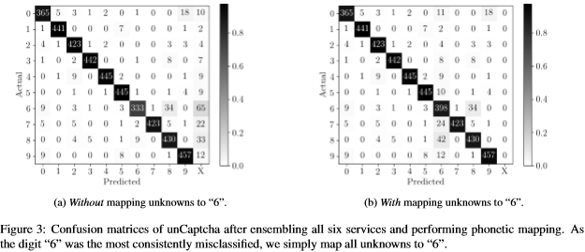
Figure 3 presents confusion matrices that show how unCaptcha performs on a per-digit basis. The column labeled “X” in the confusion matrices represents a failure to produce a digit, meaning that unCaptcha could not even identify the sound bite as a numeral. As can be seen Figure 2: The distribution of digits sampled from reCaptcha, and the number unCaptcha successfully detected. in Figure 3(a), the majority of errors came from misclassifying the digit “6”.
Improving the accuracy of “6” After noticing the low accuracy of “6”, we imposed a crude (but surprisingly effective) countermeasure: we simply map all unknowns (“X”) to “6”, giving us the confusion matrix in Figure 3(b). This improved unCaptcha’s per-digit accuracy from 91.99% to 93.41%, and overall captcha success rate from 80.31% to 85.15% (this includes all 6 services and both layers of phonetic mapping).
The success of unCaptcha’s ensembling approach can be seen in comparing the overall confusion matrix in Figure 3(a) with the top performing services in Figures 5(b), 6(b), and 7(b); only the services working together were capable of defeating reCaptcha.
Captcha success rate unCaptcha successfully solved reCaptcha’s auditory challenges with an overall success rate of 85.15%. This can be explained by two observations. First, reCaptcha requires only 9 of the 10 digits to be successfully identified in order to pass the captcha. We can thus view each digit as an independent trial. Second, as is shown in Figure 2, the distribution of digits is approximately uniform, and thus captcha success rate can be modeled with a simple binomial distribution, with a success probability equal to our per-digit accuracy of 93.41%. In testing, we also encountered no limitations on the number of times we could automatically request a new challenge. This weakness allows for even more accurate attacks; for example, an attacker could repeatedly request new audio challenges until it had higher confidence in its solution.
5.5 unCaptcha Speed
Recall that unCaptcha issues 10 (single-digit) queries to each of 6 online speech recognition services. This is an embarrassingly parallelizable task: the services are independent of one another, and thus an attacker can query them in parallel. We implemented two variants of unCaptcha: one that solves each digit serially, and one that solves them in parallel.
Solving each digitally serially resulted in an average captcha completion time of 22.24 sec. Solving them in parallel, unCaptcha took 5.42 sec on average with a standard deviation of 1.25 sec, a significant improvement in speed.
The audio captchas we captured were on average 19.13 sec long, with a standard deviation of 2.39 sec. We hypothesized that we would have to wait for the duration of the entire audio clip before entering our solution for it to be valid, but surprisingly, reCaptcha allowed solutions to be submitted faster than the audio could play.
In short, the time it takes unCaptcha to solve reCaptcha’s auditory challenges is on average 28.3% of the time it would take for a human to listen to them. As such, reCaptcha’s primary bottleneck on attack speed is service response times.
5.6 Service Response Times
Across all six speech-to-text services unCaptcha uses, we observed an average response time of 2.95 sec, with a standard deviation of 1.99 sec. However, recall that unCaptcha uses the free tiers of these services; response times can go up considerably (or the services can become unavailable) after exhausting the free allotment.
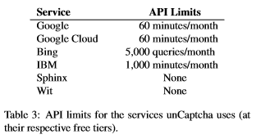
Although a few of the services are free to use, others limit the user based on number of queries or minutes of audio, as shown in Table 3. After this period, users have to decide either to sign up for a new account (to access new API keys) or pay for the service. Ironically, a reCaptcha captcha is the only defense against bot registration for a new account on many of these services, meaning that unCaptcha could theoretically be made self-sufficient by automatically signing up for a new account if it detects that a given account is close to its API limit.
5.7 Library Size Estimation
Throughout the process of manually solving each captcha, we noticed a significant number of the individual digits were repeated. We investigate this duplicate rate to see if we could estimate the library size of the reCaptcha’s audio files. If the library size is too small, reCaptcha could be vulnerable to an attack where the attacker downloads all possible digits, classifies each of them, and automatically compares each digit from an unsolved captcha with the already-classified digits. Ideally, a captcha system would have none of these duplicates, so that such an attack would not work.
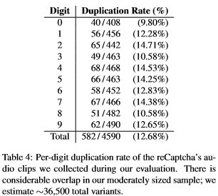
To determine the number of duplications, we classified each audio segment as its respective digit and analyzed the Mel-Frequency Cepstral Coefficients (MFCCs) of all digits. We found a non-negligible occurrence of these duplicates; Table 4 shows that, of the 4590 total per-digit audio samples we received, 12.68% of them were repeats. Using the capture-recapture [10] method to estimate the overall population size, we estimate that Google stores approximately 3600 files per digit in its database, from which it randomly selects files to generate a captcha, implying an overall library size of about 36,500 digits. The entire audio captcha (10 digits) file size approximately 30KB, meaning the estimated library size constitutes ∼110 MB, well within the storage capacity of a low-resource attacker. Classification would require a comparison between the test digit and the stored digits, which could take a significant amount of time. However, other means of comparison, such as through the use of perceptual hashing [9], could drastically reduce the comparison time and make an attack feasible for a low-resource attacker.
6 Conclusion
As we have shown, unCaptcha provides a highly successful, low-resource defeat of reCaptcha. Our system was able to solve 450 separate captchas with 85.15% success in an average of 5.42 seconds. unCaptcha’s unique ensembling and postprocessing scheme is what makes it considerably more successful than any prior efforts to defeat reCaptcha. This work presents a significant issue to Google’s system, as any attacker could use this system to sign up for thousands of accounts for any websites using reCaptcha. After raising concerns about the security of the system to Google, they responded by making major changes to the reCaptcha system, which made this attack obsolete.

Chapter 2: unCaptcha2
1 Introduction
After our public disclosure of the unCaptcha attack in October, 2018 (located at https://github.com/ecthros/uncaptcha), Google made two significant changes to reCaptcha to make it more difficult for automated attackers. The two main changes were better browser automation detection and using spoken phrases, probably from short YouTube clips, rather than digits. This made the original attack obsolete, as the attack relies on the homophone mapping and Selenium. Since the solution space is much larger – there are thousands of possible words for answers with the second version of reCaptcha, while there were only ten possibilities in the first version – we can no longer use the homophone mapping. Additionally, we need another way to automate the process, since browsers like Selenium are no longer effective.
Although at first glance these changes may make it seem like the system was made much more robust, using short spoken phrases actually makes the attack significantly easier. This is due to the fact that the clips are very short – between three and seven seconds – and speech-to-text engines are incentivized to solve these types of clips, in contrast with ten separate sound bites. Speech-to-text engines are significantly more effective when they have context for each word, and since the phrases are spoken by the same person, these engines are much more accurate as they can use the advantage of context clues. Additionally, as we will show, it is trivial to bypass reCaptcha’s browser automation detection in practice.
This chapter presents unCaptcha2, a low-resource, fully automated attack on Google’s 2018 and 2019 reCaptcha audio challenge. unCaptcha2 provides several improvements over the initial version. It is even more viable for a low-resourced attacker, as it only needs a single publicly-available speech recognition service. Using a local Virtual Machine without many resources, we show that unCaptcha2 solves reCaptcha’s newest audio challenges with 90.1% accuracy in 4.1 seconds, on average. Additionally, we provide a method attackers can use that demonstrates a defeat of reCaptcha’s browser automation detection, and coupled with the captcha solving, unCaptcha2 can be considered a complete defeat of the reCaptcha system. In Section 2, we will explore the design of unCaptcha2, and in Section 3 we will evaluate its effectiveness.
2 unCaptcha2 Design
The design of unCaptcha2 is considerably simpler than unCaptcha. There are two major parts to solving the changes presented by the new version of reCaptcha: the browser automation detection and the new challenges reCaptcha has. Both can be solved with simple workarounds.
2.1 Browser Automation Detection
The new version of reCaptcha decides if a user is using an automatic browser, such as Selenium, to prevent the attack from the first version of unCaptcha. If this detection is perfect, then attackers would not be able to automate their captcha solving, even if it was a highly successful defeat of the challenges. As a result, it is imperative unCaptcha2 can evade this detection.
Selenium injects client-side JavaScript into the page itself. However, since this resource is shared, reCaptcha authors have access to this JavaScript and can check for Selenium. Some [32] have suggested checking the page for the presence of a variable called “_cdc.” If this variable is present, it is highly likely that the client is using Selenium. However, after modifying Selenium to remove this variable, reCaptcha was still able to detect that the browser was automated. There are several variables that reCaptcha could check for the presence of Selenium, or it could be using other tactics, such as looking for patterns in the client-side code or other side effects the browser had.
Efforts to reverse engineer reCaptcha also proved futile. If one could determine what the reCaptcha code was doing, then it would probably be trivial to evade the browser automation detection. However, the code is heavily obfuscated and very little progress was made even after several hours of reverse engineering. Although this is a promising area for future research, due to the complexity of the code, we decided to stop looking at the obfuscated reCaptcha code in favor of a simpler solution.
Rather than evading the reCaptcha code, it is much easier to use a normal browser and fake the higher-level movements, such as the mouse and keyboard. For example, we used the Firefox browser and python’s popular pyautogui library to move the cursor as needed. This allowed us to programmatically open up Firefox, navigate to a website with reCaptcha enabled, download the captcha, and submit the solution. Although this approach is effective, it is not optimal; there are still occasionally issues (about .8% of the time) due to long loading speeds or Firefox rendering issues.
2.2 New reCaptcha Challenges
As noted above, the new challenges presented by reCaptcha are much simpler to solve than ever before. Rather than ensembling six different services with a complex homophone mapping, unCaptcha2 only requires a single speech-to-text service. For evaluation purposes, we chose two separate services: Google’s and Microsoft’s. Like before, the code still supports other speech services to show that an attacker could choose any one of them and still be successful.
3 Evaluation
3.1 unCaptcha2 Accuracy
unCaptcha2 is even more accurate than its predecessor, since speech services can use context clues to solve the challenges better. Solving these captchas is simple: use the above approach to navigate to the website and download the captcha. Then, upload the captcha to Google’s speech-to-text service, get the response, and input the response. Over the 538 captchas that we tried, Google’s service was 90.1% effective. By contrast, Microsoft’s service was right behind Google’s at 87.7%. We believe that the small improvement was probably because Google’s speech service constantly improves as people submits these captchas, and it has probably used them in some way to train the system.
3.2 unCaptcha2 Speed
Furthermore, the amount of time it takes to solve a captcha is almost solely dependent on the latency of the network connection. Since we only have to make a single request to one speech-to-text service, without any postprocessing of the data, unCaptcha2 is incredibly fast. This process took about 2.62 seconds for Google’s API and 2.71 seconds for Microsoft’s API. However, these could probably both be sped up significantly with a better Internet connection or by requesting that the APIs were located closer to the client. However, since both were so fast to begin with, we did not try to make the attack better past this point.
4 Conclusion
While further improvements could be made to make unCaptcha2 both more successful and faster, we believe that it still represents a very pressing vulnerability. The proof of concept code can be found at https://github.com/ecthros/uncaptcha2, which will also have each of the captchas used for evaluation once the system has been completely fixed. The attack presented by unCaptcha2 shows that the fix Google implemented was made too quickly, without proper thought about the repercussions of changing the captchas from digits to short phrases. Additionally, it shows the cat-and-mouse game that attackers and captcha creators are currently undergoing: as AI and machine learning get better, attackers can use these tools against captchas. Since captcha creators want to be able to use those captchas to train their own systems, AI will implicitly get better at solving captchas over time. Since everyone has access to these AI endpoints – Google makes them freely available with a trial version – attackers can simply use them against the captchas. Although we have shown Google this project, we hope that Google can use it to improve the system and come up with problems that AI is not already trying to solve so this cat-and-mouse game can conclude. We will explore countermeasures that Google could take, along with the ethical considerations of releasing this project and the future security of captchas, in the next chapter.

Chapter 3: Discussion
1 Introduction
unCaptcha has proved to be a very effective method of solving captchas, both currently and in the past. However, releasing code that solves captchas does not capture the essence of what we want this project to be. Instead, we want to improve the captcha ecosystem and prevent these attacks from working in the first place. To achieve this goal, we notified Google of both attacks before releasing the code, and worked with Google to help them understand why our attack worked and how similar attacks could be effective without a large overhaul of reCaptcha. In this chapter, we will explore the countermeasures that Google could take to improve the system and the ethical considerations of releasing the code.
2 Countermeasures
In this section, we discuss some potential countermeasures to make the reCaptcha system and similar auditory captchas more robust to withstand this attack.
2.1 Vocabulary Size
Improving the security of reCaptcha’s audio captchas is critical since passing an auditory captcha bypasses reCaptcha entirely. Checking for simple impossibilities, such as moving the mouse faster than a human possibly could, clicking the precise center of an element, or solving captchas faster than they can be heard would help bolster security against less sophisticated bots. In the immediate term, reCaptcha resiliency can be improved by broadening the vocabulary of sound bites beyond just digits. Our system of phonetic mapping relies on this vocabulary of 10 elements; if a vocabulary of all spoken words was used instead, it would be much more difficult to detect or even correct errors from the speech to text services using a simple phonetic mapping.
2.2 Distortion
Adding background noise or background chatter between digits to would make segmentation more difficult. (For example, Amazon Web Services implements this for their audio captcha.) However, to make the actual digits to identify stand out to the user, this background noise often needs to be quieter than the actual digits to identify, making it susceptible for easy removal or identification with a low-pass filter. Similar analysis can also remove high-frequency noise, general distortion, or chatter from periods without digits, making segmentation still relatively easy. Recent studies support this, and have shown that background noise is largely ineffective at impeding automatic speech recognition [20]. Other audio based tasks that were previously thought to only be doable by humans, such as song identification, have also been solved with a very high degree of accuracy [30].
As speech recognition systems get stronger and more resilient to background noise and distortion, maintaining the security of the audio captcha in its current form will prove more difficult. In 2008, Tam et al. suggested taking advantage of the human ability to understand distorted audio through context clues. By replacing random isolated words or digits with familiar phrases or sentences, the idea was that humans could decipher distorted utterances through familiarity with the phrase or contextual clues in the sentence [26]. However, we believe this is not a viable long-term solution, particularly given the advancements in neural networks and other advanced speech recognition services taking advantage of contextual clues [31, 17, 19].
2.3 Auditory Instructions
We suggest a different approach: giving auditory instructions to the user to follow. For example, instead of challenging the user with a sound to transcribe (or identify), an automated series of tasks could be read to the user. Even simple tasks like “move your mouse upwards,” “type a word,” “type the following word but don’t type this word,” etc. could prove far more difficult for a computer to solve, as it adds an additional layer to the challenge. Beyond blind segmentation and transcription, understanding the challenge commands would require a host of custom processing, particularly since it would be relatively easy for the captcha system to build up a large vocabulary of similar commands. Such a challenge is also more truly akin to a Turing test. Although making audio captchas more difficult for machines has been traditionally associated with also making it harder for humans, we believe this higher level test would be easy for humans to solve while proving difficult for bots.
3 Responsible Disclosure
The day after we had a working prototype of unCaptcha (mid-March 2017), we emailed the Google BotGuard team to inform them of the weaknesses we discovered. They reported that they were aware of the issues and were working on a fix. As of mid-July 2017, Google told us minor updates to reCaptcha had been made tightening the security of the audio captcha specifically. This was true: reCaptcha was updated with better browser automation detection and phrases rather than digits.
By June, 2018, we had another working prototype, this time of unCaptcha2. Shortly afterwards, we updated Google with our findings, but they were less responsive about fixing the issues. Although they were interested in the attack and preventing it, they had not updated reCaptcha within six months of the disclosure. Industry standard dictates that a company typically receives at least six weeks after disclosure before researchers should publish their results. Therefore, we felt that this waiting period of six months was more than enough time for Google to fix this, and we published our findings to Github in December, 2018.
We reported each step of our findings to Google in the hopes they would improve the overall security of the system; however, our cycle brings up several interesting ethical considerations. Is it ethical to attack these systems? If the code is leaked for any reasons before disclosure, attackers may be able to quickly weaponize the techniques for nefarious purposes. However, we feel that researchers testing the limits of systems like unCaptcha is paramount to its security, not detrimental. This is since companies are incentivized not to have these attacks and will spend more resources preventing them in the future. Furthermore, if there is a simple technique that others may find, reporting the findings to the company will help improve the overall security of captchas.
4 Conclusion
We demonstrate two low-resource, high accuracy defeats of the reCaptcha system. Both systems achieved over 85% accuracy on captchas. This carries major consequences; reCaptcha is used by hundreds of thousands of sites as one of the foremost lines of defense against service abuse and automated account creation. We make a number of suggestions to mitigate our attack and reaffirm the security of the reCaptcha, providing a third line of computational defense against bots for auditory captcha systems. In the future, we look to explore the efficacy of our attack methodology on other auditory captcha systems, including Amazon’s auditory captcha, eBay’s, and more. We also seek to explore if this similar low-resource methodology of using free, online public services can be used to attacking reCaptcha’s image captcha. The code and data from this paper are publicly available at https://uncaptcha.cs.umd.edu/.

11 References
[1] E. Bursztein, J. Aigrain, A. Moscicki, and J. C. Mitchell. The end is nigh: Generic solving of text-based captchas. In WOOT, 2014.
[2] E. Bursztein and S. Bethard. Decaptcha: Breaking 75% of eBay audio CAPTCHAs. In WOOT, 2009.
[3] K. Chellapilla, K. Larson, P. Y. Simard, and M. Czerwinski. Building segmentation based human-friendly human interaction proofs (HIPs). In Human interactive proofs, pages 1–26. Springer, 2005.
[4] J. R. Douceur. The Sybil attack. In IPTPS, 2002.
[5] Z. Durumeric, D. Adrian, A. Mirian, M. Bailey, and J. A. Halderman. A search engine backed by internet-wide scanning. In CCS, 2015.
[6] ETSI Standard. Speech processing, transmission and quality aspects (STQ); distributed speech recognition; frontend feature extraction algorithm; compression algorithms. ETSI ES, 201(108):V1, 2003.
[7] T. Ganchev, N. Fakotakis, and G. Kokkinakis. Comparative evaluation of various MFCC implementations on the speaker verification task. In SPECOM, 2005.
[8] Google reCAPTCHA. https://www.google.com/ recaptcha/intro/.
[9] N. M. Hamza zer, Blent Sankur. Robust audio hashing for audio identification. EUSIPCO, 2004.
[10] S. Hjsgaard. The Capture-Recapture Model for Estimating Population Size. Department of Mathematical Sciences, Aalborg University, 2014.
[11] S. Khattak, D. Fifield, S. Afroz, M. Javed, S. Sundaresan, V. Paxson, S. J. Murdoch, and D. McCoy. Do you see what I see? Differential treatment of anonymous users. In NDSS, 2016.
[12] G. Kochanski, D. P. Lopresti, and C. Shih. A reverse turing test using speech. In INTERSPEECH, 2002.
[13] S. Li, S. A. H. Shah, M. A. U. Khan, S. A. Khayam, A.-R. Sadeghi, and R. Schmitz. Breaking e-banking CAPTCHAs. In ACSAC, 2010.
[14] L. Muda, M. Begam, and I. Elamvazuthi. Voice recognition algorithms using mel frequency cepstral coefficient (MFCC) and dynamic time warping (DTW) techniques. arXiv preprint arXiv:1003.4083, 2010.
[15] neuroradiology. InsideReCaptcha. https://github.com/neuroradiology/InsideReCaptcha, 2014.
[16] M. Prince. The trouble with Tor. CloudFlare Blog (https://blog.cloudflare.com/the-trouble-with-tor/), Mar. 2016.
[17] J. Rao, F. Ture, H. He, O. Jojic, and J. Lin. Talking to your TV: Context-aware voice search with hierarchical recurrent neural networks. arXiv preprint arXiv:1705.04892, 2017.
[18] ReBreakCaptcha: Breaking Googles ReCaptcha v2 using.. Google. https://eastee.com/2017/02/28/rebreakcaptcha-breaking-googlesrecaptcha-v2-using-google/, Feb. 2017.
[19] Y. Ren, Y. Zhang, M. Zhang, and D. Ji. Context-sensitive twitter sentiment classification using neural network. In AAAI, 2016.
[20] S. Sano, T. Otsuka, and H. G. Okuno. Solving Google’s continuous audio CAPTCHA with HMM-based automatic speech recognition. In IWSEC, 2013.
[21] R. Santamarta. Breaking Gmails Audio Captcha. Archived: https://web.archive.org/web/ 20131214022419/ http://blog.wintercore.com/2008/03/05/breaking-gmailsaudio-captcha/, 2008.
[22] Simplecaptcha. http://simplecaptcha.sourceforge.net.
[23] S. Sivakorn, J. Polakis, and A. D. Keromytis. I’m not a human: Breaking the Google reCAPTCHA. Black Hat, 2016.
[24] Y. Soupionis and D. Gritzalis. Audio CAPTCHA: Existing solutions assessment and a new implementation for VoIP telephony. Computers & Security, 29(5):603–618, 2010.
[25] Stiltwalker: Nucaptcha, Paypal, SecurImage, Slashdot, Davids Summer Communication. http://www.dc949.org/projects/stiltwalker/, 2012.
[26] J. Tam, J. Simsa, D. Huggins-Daines, L. Von Ahn, and M. Blum. Improving audio captchas. In SOUPS, 2008.
[27] J. Tam, J. Simsa, S. Hyde, and L. Von Ahn. Breaking audio captchas. In NIPS, 2008.
[28] Using deep learning to break a captcha system. https://deepmlblog.wordpress.com/2016/01/03/ how-tobreak-a-captcha-system/, Jan. 2016.
[29] O. Varol, E. Ferrara, C. A. Davis, F. Menczer, and A. Flammini. Online human-bot interactions: Detection, estimation, and characterization. arXiv preprint arXiv:1703.03107, 2017.
[30] A. Wang. The Shazam music recognition service. Communications of the ACM, 49(8):44–48, Aug. 2006.
[31] B. D. Whissel. Speaker-independent phoneme recognition in a continuous speech context using time-delay feed-forward neural networks. http://bretwhissel.net/portfolio/the paper.pdf.
[32] J. Yan and A. S. El Ahmad. A low-cost attack on a Microsoft CAPTCHA. In CCS, 2008.
[33] colossatr0n. Can a website detect when you are using Selenium with Chromedriver. https://stackoverflow.com/questions/33225947/can-a-website-detect-when-you-are-using-selenium-with-chromedriver. August 31, 2018.

Appendix
Confusion Matrices
We present below the confusion matrices for each of the six services that unCaptcha uses. When the service is unable to predict a digit, we denote its predicted value as “X”.
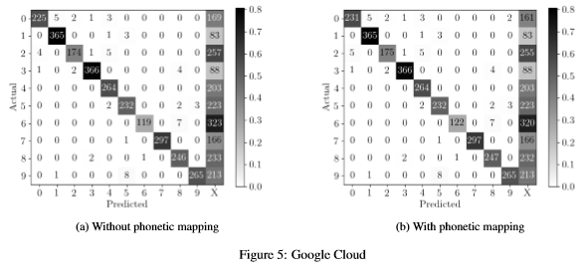
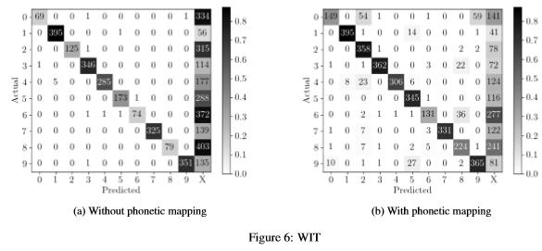
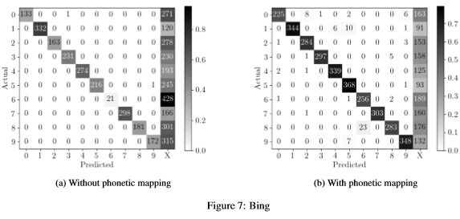
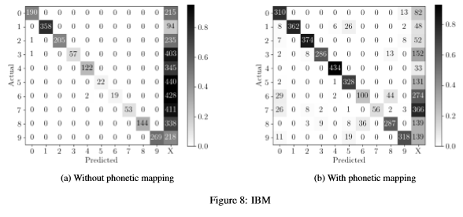
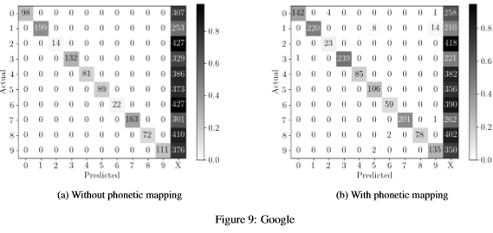
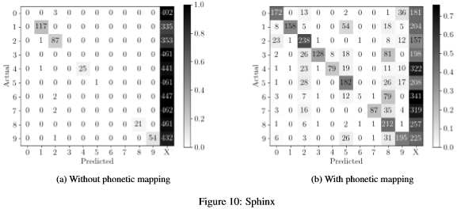

For the remainder of the paper, we follow industry convention and write the acronym in lowercase, as “captcha”, for readability.
Google does not publish reCaptcha usage statistics. We make this conservative estimate using a Censys [5] search for “recaptcha”.
For ease of comparison between resource levels, all of our benchmark testing for the ‘low-resource’ attacker was done on a free-tier Amazon Elastic Computing t2.micro instance, with 1GB of RAM, 1 virtual CPU, and 8GB of storage.
https://www.seleniumhq.org
https://cloud.google.com/speech/
https://microsoft.com/cognitive-services/en-us/speech-api
https://ibm.com/watson/developercloud/doc/speech-to-text/
https://wit.ai/
http://cmusphinx.sourceforge.net/wiki/
https://pypi.python.org/pypi/SpeechRecognition/
Although during the initial data collection phase 500 captchas were attacked and downloaded for analysis, 41 captchas were accidentally overwritten, leaving a test set of 459 captchas.
Note that this duplicate rate is only a conservative lower-bound estimate, and the true duplication rate is likely higher than this.
https://pyautogui.readthedocs.io/en/latest/

